To understand and enjoy American football, get familiar with key terms and what they mean. Until you grasp basic football lingo, listening to announcers call a football game can be like listening to monkey gibberish. The following list fills you in on the basic American football terms you need to know:
Football Diagram
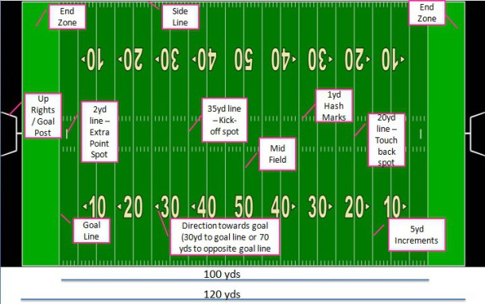
- Sideline – The sideline is the boundary line that runs the length of each side of the football field.
- End line – The end line is a boundary line that connects the two parallel sidelines. The end line and sideline compose the rectangular shape of the field. Two pylons flank the end of the end line.
- End zone – The end zones are areas at each end of the field inside the end line. The end zone behind a team is that team’s end zone, and the end zone ahead of a team is its opponent’s end zone.
- Goal line – The goal line is a line that runs across the front of the end zone. Two pylons flank the end of the goal line.
- Yard lines and hash marks – In the 100 yards (91 meters) between goal lines, hash marks on either side of the field mark each yard. At every fifth yard, a solid white line runs from sideline to sideline, and at every 10 yards those lines are numbered (i.e., 10, 20, 30, 40, etc.). This crosshatch of lines gives the field its “gridiron” nickname.
- Goalposts – Centered at the back of the end zone is a pole that extends 10 feet (3 meters) high and connects with a horizontal cross bar. On each end of the 18-foot, 6-inch (5.5-meter) cross bar is an upright post that rises to a height of 30 feet (9 meters) above the ground. A 4-inch by 42-inch (10-cm x 107-cm) ribbon is tied to the top of each upright

BASIC FOOTBALL TERMINOLOGY
- Backfield: The group of offensive players — the running backs and quarterback — who line up behind the line of scrimmage.
- Down: A period of action that starts when the ball is put into play and ends when the ball is ruled dead (meaning the play is completed).
- Drive: The series of plays when the offense has the football, until it punts or scores and the other team gets possession of the ball.
- End zone: A 10-yard-long area at each end of the field. You score a touchdown when you enter the end zone in control of the football
- Extra point: A kick, worth one point, that’s typically attempted after every touchdown (it’s also known as the point after touchdown, or PAT). It must sail between the uprights and above the crossbar of the goalpost to be considered good.
- Fair catch: When the player returning a punt waves his extended arm from side to side over his head. After signaling for a fair catch, a player can’t run with the ball, and those attempting to tackle him can’t touch him.
- Field goal: A kick, worth three points, that can be attempted from anywhere on the field and like an extra point, a kick must sail above the crossbar and between the uprights of the goalpost to be ruled good.
- Fumble: The act of losing possession of the ball while running with it or being tackled.
- Handoff: The act of giving the ball to another player. Handoffs usually occur between the quarterback and a running back.
- Hash marks: The lines on the center of the field that signify 1 yard on the field. Before every play, the ball is spotted between the hash marks or on the hash marks, depending on where the ball carrier was tackled on the preceding play.
- Huddle: When the 11 players on the field come together to discuss strategy between plays. On offense, the quarterback relays the plays in the huddle.
- Incompletion: A forward pass that falls to the ground because no receiver could catch it, or a pass that a receiver dropped or caught out of bounds.
- Interception: A pass that’s caught by a defensive player, ending the offense’s possession of the ball.
- Kickoff: A kickoff is used at the start of the first and third quarters and after every touchdown and successful field goal.
- Line of scrimmage: An imaginary line that extends from where the football is placed at the end of a play to both sides of the field.
- Offensive line: Every line has a center (who snaps the ball), two guards, and two tackles.
- Punt: A kick made when a player drops the ball and kicks it while it falls toward his foot.
- Red zone: The unofficial area from the 20-yard line to the opponent’s goal line.
- Sack: When a defensive player tackles the quarterback behind the line of scrimmage for a loss of yardage.
- Safety: A score, worth two points, that the defense earns by tackling an offensive player in possession of the ball in his own end zone.
- Special teams: The 22 players who are on the field during kicks and punts.
- Touchdown: A score, worth six points, that occurs when a player in possession of the ball crosses the plane of the opponent’s goal line.

